Digital Image Restoration

A PROJECT REPORT

Submitted by

Ashutosh Shukla(111224)
Samrita Bakshi(111281)
Shivam Goyal(111290)

Under the Supervision of: Dr. Vipin Tyagi


MAY 2015

Submitted in partial fulfillment of the degree
of
BACHELOR OF TECHNOLOGY
IN
COMPUTER SCIENCE & ENGINEERING

Department of Computer Science & Engineering
JAYPEE UNIVERSITY OF ENGINEERING & TECHNOLOGY,
AB ROAD, RAGHOGARH, DT. GUNA – 473226 MP, INDIA
DECLARATION BY STUDENT
I hereby declare that the work reported in the B. Tech. project entitled as “Digital Image Restoration”, in partial fulfillment for the award of degree of B.Tech submitted at Jaypee University of Engineering and Technology, Guna, as per best of my knowledge and belief there is no infringement of intellectual property right and copyright. In case of any violation I will solely be responsible.

Ashutosh Shukla (111224)
Samrita Sen Bakshi (111281)
Shivam Goyal (111290)
Department of Computer Science and Engineering
Jaypee University of Engineering and Technology
Guna, M.P., India
Date: 18/05/2015

CERTIFICATE

This is to certify that the work titled “Digital Image Restoration” submitted by “Ashutosh Shukla , Samrita Sen Bakshi, Shivam Goyal in partial fulfillment for the award of degree of B.Tech of Jaypee University Of Engineering & Technology, Guna has been carried out under my supervision. As per best of my knowledge and belief there is no infringement of intellectual property right and copyright. Also, this work has not been submitted partially or wholly to any other University or Institute for the award of this or any other degree or diploma. In case of any violation concern student will solely be responsible.

Dr Vipin Tyagi
Computer Science & Engineering Department,
Jaypee University of Engineering & Technology,
Guna,India.
Date:

ACKNOWLEDGEMENT

We are greatly indebted to our project supervisor have Dr Vipin Tyagi, Department of Computer Science and Engineering, Jaypee University Of Engineering and Technology, Guna, for inspiring and motivating us to develop ideas and implementing them. We are grateful to him for his invaluable guidance and encouragement for the project. We would like to take this opportunity to express our sincere and profound gratitude to him for the pains he has taken for the project.

Ashutosh Shukla Samrita Sen Bakshi Shivam Goyal (111224) (111281) (111290)

EXECUTIVE SUMMARY

Image restoration is the operation of taking a degraded image and estimating the clean original image. Degradation in an image occurs primarily due to blur and noise. Restoration attempts to reconstruct or recover an image that has been degraded by using a priori knowledge of the degradation phenomenon. Thus restoration techniques are oriented toward modeling the degradation and applying the inverse process in order to recover the original image. This report starts with basic model of image degradation/restoration process and proceeds towards enlisting commonly occurring blurs and noises. Thereafter, it reviews some spatial and frequency domain filters for restoration of only noisy images.
The main goal of the project is to analyze the methods of digital image processing that are used to enhance an image. This project included the main concept of digital image processing, how to process it using some techniques and compare the techniques and suggest which one is easy to deal with digital images. The targets of the techniques include reducing noise, contrast enhancement and image sharpening. This project also analyzed the methods on color images and suggested the ways in order to restore images.

LIST OF FIGURES

Figure No. | Figure Name | Page No.
Figure 1.1 | Creation of Digital Image | 2
Figure 1.2 | Pixel Representation on Coordinates | 3
Figure 1.3 | Digital Image Representation | 4
Figure 1.4 | Matrix Representation of Image | 4
Figure 1.5 | Model of Image Degradation Process | 6
Figure 1.6 | Image Degradation | 7
Figure 1.7 | Gaussian Noise | 10
Figure 1.8 | Uniform and Salt and Pepper Noise | 11
Figure 3.1 | Image Denoising | 22
Figure 3.2 | Multilevel Wavelet Decomposition of a Signal | 23
Figure 3.3 | Wavelet Decomposition of an Image | 24
Figure 3.4 | Wavelet Decomposition of Degraded Image | 25
Figure 3.5 | Selected Wavelets | 27
Figure 3.6 | Plot of Hard Thresholding | 34
Figure 3.7 | Plot of Soft Thresholding | 35
Figure 3.8 | Image Denoising Method | 38
Figure 3.9 | Diagram of the Proposed Denoising Method | 38
Figure 3.10 | Classification of Denoising Techniques | 39
Figure 4.1 | Comparing the performance of noisy Lena with Soft, Hard and Proposed Shrink Method | 41
Figure 4.2 | Flow Chart of the Algorithm | 42
Figure 4.3 | Flow Chart for Wavelet Denoising | 43

LIST OF TABLES
Table No. | Table Name | Page No.
Table 3.1 | Comparison Results of Selected Wavelet (PSNR) | 27
Table 3.2 | Several Common Wavelets Application Performance Analysis Wavelet function Haar | 28
Table 5.1 | Comparison Parameters for Soft Thresholding | 47
Table 5.2 | Comparison Parameters for Hard Thresholding | 48
Table 5.3 | Results of Proposed Algorithm for different Wavelets | 48

TABLE OF CONTENTS

Declaration by Student | ii
Certificate | iii
Acknowledgment | iv
Executive Summary | v
List of Figures | vi
List of Tables | viii

1 | Introduction | 1
 | 1.1 Introduction to Image Processing | 1
 | 1.2 Digital Image Processing | 1
 | 1.3 Basics of Image Sampling and Quantization | 3
 | 1.4 Digital Image Representation | 4
 | 1.5 Image Restoration | 5
 | 1.5.1 Basic Model For Digital Image Restoration | 6
 | 1.5.2 Primary Causes For Image Degradation | 7
 | 1.5.3 Noise Types | 9
 | 1.6 Applications of Image Restoration | 11
2 | Literature Review | 13
 | 2.1 Spatial and Frequency Domain Filters for Restoring Noisy Images | 13
 | 2.2 Adaptive edge-preserving image denoising using wavelet transforms | 14
 | 2.3 Wavelet-domain Image Restoration Model Based on Variation Regularization | 15
 | 2.4 Adaptive Wavelet Thresholding for Image Denoising and Compression | 17
 | 2.5 Denoising Using Soft Thresholding | 19
3 | Image Denoising | 21
 | 3.1 Image denoising by wavelet thresholding | 22
 | 3.2.The Selection of Wavelet | 25
 | 3.3.Threshold Estimation | 29
 | 3.3.1 Shrinkage rules | 30
 | 3.3.2 Hard Thresholding | 33
 | 3.3.3 Soft Thresholding | 34
 | 3.3.4 Thresholding Algorithms | 35
 | 3.4 Image Denoising Method | 37
4 | Proposed Methodology | 40
 | 4.1 Adaptive Thresholding Function | 40
 | 4.2 Implementation-Wavelet Denoising | 42
 | 4.3 Proposed Algorithm | 44
 | 4.4 Technology Used | 45
 | 4.4.1 MATLAB | 45
 | 4.4.2 Image Processing Toolbox | 45
 | 4.4.3 System Requirements | 46
5 | Experimental Results | 47
6 | Conclusion and Future Extension | 49
 | 6.1 Conclusion | 49
 | 6.2 Future Extension | 49
 | Appendices | 50
 | A | 50
 | B | 57
 | References | 60

CHAPTER 1
INTRODUCTION

1.1 Introduction to Image Processing
The main goal is to show how a digital image is being processed and as the result to have a better quality picture. The digital images are going to be enhanced using spatial and frequency domain methods .The images are going to be enhanced with the mentioned methods and those methods have their own approaches. However all they do is enhancing an image with a better quality.
The main targets of the techniques mentioned include noise reduction, contrast enhancement and image restoration. In this report we are going to discuss these targets in brief. This topic is chosen to show the importance in our real life such as in Medical fields, astronomy, forensics, photography, game industry, and biological researches. Image processing is the core of many scientific researches and fields .But nowadays the image processing is implemented using digital systems such as simple computer chips. Therefore certain digital image processing approaches methods are needed in order to processes those digital images. Here in this project we have tried to implement some of the methods.

1.2 Digital Image Processing
Image processing[1] deals with analysis of images using different techniques. Image processing deals with the any action to change an image. Image processing has different methods like optical, analog and digital image processing. Digital image processing is a part of signal processing where we processes digital images using computer algorithms. The computer algorithms can be modified so that we can also change the appearance of the digital image easily and quickly. Digital image processing has numerous applications in different studies and researches of science and technology. Some of fields that use digital image processing include: biological researches, finger print analysis in forensics, medical fields, photography and publishing fields, astronomy, and in the film and game industries
- Image enhancement: image enhancement deals with contrast enhancement, spatial filtering, frequency domain filtering, edge enhancement and noise reduction.
- Image restoration: The image is corrected using different correction methods like inverse filtering and feature extraction in order to restore an image to its original form.
- Image analysis: This information helps in image restoration and enhancement. One of the representations of the information is the histogram representation to show the brightness and darkness in order to arrange and stretch the images to have an enhanced image relative to the original image.
- Image compression: Image compression deals with the compression of the size of the image so that it can easily be stored electronically. The compressed images are then decompressed to their original forms. Here the image compression and decompression can either lose their size by maintaining high quality or preserves the original data size without losing size.
- Image synthesis: this class of digital image processing is well known nowadays in the film and game industry. Nowadays the film and game industry is very advanced in 3-dimensional and 4-dimensional productions. In both cases the images and videos scenes are constructed using certain techniques. The image synthesis has two forms tomography and visualization

The Fig 1.1 shown below shows how a Digital Image is actually formed.
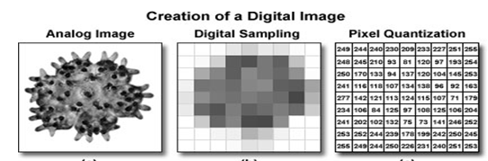
Fig 1.1 Creation of a Digital Image
1.3 Basics of Image Sampling and Quantization
An image consists of pixels that have a rectangular shape. Each pixel can be represented on a coordinate system as a function f(x,y) where x and y representing the column and the row of the pixels within the image In Fig 1.2 the pixel coordinate shows the f (r, c) are similar to f(x, y) and they show the position of the coordinates. c and r represent the x and y coordinates respectively. A continuous image can be represented as a function f(x ,y) and amplitude. The digitization of the coordinates is called sampling ,while the digitization of the amplitude values is called quantization.

(0,0) | (0,1) | (0,3) | (0,4)
(1,0) | (1,2) | (1,3) | (1,4)
(2,0) | (2,1) | (2,2) | (2,3)
(3,0) | (3,1) | (3,2) | (3,3)

Fig 1.2 Pixel representation on coordinate

1.4 Digital Image Representation
A continuous image is sampled and quantized in order to be digitized. The sampling and quantization are represented in a form of matrix. The matrix representations can be M x N where M represents the x-coordinates while N represents the y-coordinates as shown in Fig. 1.3

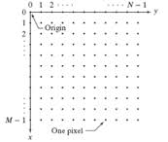
Fig 1.3 Digital image representations
As it can be seen in Fig 1.3 the f (x, y) = (0, 0) is taken as f (r, c) = (1, 1). The M and N representing the rows and columns respectively. Therefore for matrix representation the following can be used as shown in Fig. 1.4

$$a_{1,1}$$ | $$a_{1,2}$$ | …… | $$a_{1,n}$$
$$a_{2,1}$$ | $$a_{2,2}$$ | …… | $$a_{2,n}$$
: | : | : | :
$$a_{n,1}$$ | $$a_{n,2}$$ | …… | $a_{n,n}$

A =

Fig 1.4 Matrix Representation of an Image
where the a (1, 1) represents the a(x, y) = (0, 0) and so on. Image representation means changing it from 3-dimension to 2-dimension image space. These representations are affected by the space density and the number of the pixels in the image.

1.5 Image Restoration
Image Restoration[1] refers to a group of methods or techniques that aim to remove or reduce the degradations that have occurred while the digital image was being obtained. All natural images when displayed have gone through some sort of degradation:
- The degradation may occur during display mode
- The degradation may occur when camera is in the acquisition mode, or
- During processing mode degradations may also takes place.
- The degradation may occur due to sensor noise
- The degradations may Blur due to camera misfocus
- The degradation may occur due to relative object-camera motion
- The degradation may occur due to random atmospheric turbulence
- The degradation may occur due to some other reasons also.
An image is restored after it has lost its most important features or degraded. An image could be degraded during digitization or during transmission. During digitization or transmission a noise may be included in a digital image from the environment around it. For example, while taking a picture using a camera a noise is added by the camera fault, the image sensor or from the environment where the image is taken. When it is from the camera fault it means if the shutter speed of the camera is too long. This causes a noise type called salt-and-pepper. Image sensors are made to collect light. During collection of light more light might be collected and causes high temperature which would result in Gaussian noise type. But when it is from the environment where the image is taken it might be from light reflections. During image transmission the noise might be caused by a small bandwidth which causes the image not to transmit fully making it blur. A noise is caused by the environment around us. Therefore it is important to restore the images to their original features by removing the noise. In order to remove the noise someone has to know the noise itself so that it would be easy to remove it. Different types of noises are studied by adding them to an original image and use certain ways to remove those noises.

1.5.1 Basic Model For Digital Image Restoration

As Fig 1.5 shows, the degradation process is modeled as degradation function that, together with an additive noise term η(x, y), operates on an input image f(x, y) to produce a degraded image g(x, y). Digital image restoration may be viewed as the process of obtaining an approximation to f(x, y), given g(x, y) and a knowledge of the degradation in the form of operator H . We assume that knowledge of η(x, y) is limited to information of a statistical nature [4].

Fig 1.5 A model of image degradation process

The input-output relationship in Fig. 1.5 can be expressed as follows:
(1.1)
If H is a linear, position-invariant process, then the degraded image is given in the spatial domain by
(1.2)
(1.3)
where h(x, y) is the spatial representation of the degradation function and symbol “*” indicates 2-D convolution. Above Equation is the spatial domain representation of degradation process shown in Fig.1.5. As we know that convolution in the spatial domain is equivalent to multiplication in the frequency domain, so we may write the model in Eq. (1.3) in a frequency domain representation:
(1.4)
where the terms in capital letters are the Fourier transforms of the corresponding terms in Eq. (1.4).

1.5.2 Primary Causes For Image Degradation

There are two main causes for degradation in an image, viz, blur and noise. This section is devoted for understanding these primary causes. Orignal and Degraded Image are shown in Fig 1.6.[2]
Original Image Degraded Image
Fig. 1.6 Image Degradation
- Image Blur
Blurring is a phenomenon due to which we face difficulty in viewing image contents clearly. There are following commonly known blurs:

- Motion Blur
It represents 1-D uniform local averaging of neighboring pixels, a common result of camera panning or fast object motion, shown here for horizontal motion

1/L if –L/2 ≤ i ≤ L/2
h(i)=
0 otherwise (1.5)

- Atmospheric Turbulence Blur
Common in image sensing and aerial imaging, the blur due to long-term exposure through the atmosphere can be modeled by a Gaussian PSF
h(i, j) = Kexp[(i² +j²)/2σ²] (1.6)
where K is a normalizing constant ensuring that blur is of unit volume and σ² is the variance that determines the severity of the blur.
- Image noise
Image noise is random (not present in the object imaged) variation of brightness or color information in images, and is usually an aspect of electronic noise. The principal sources of noise in digital images arise during image acquisition (digitization) and/or transmission. Image noises can be broadly classified in two categories viz. spatially independent noise and spatially dependent noise .

- Spatially independent noise
This kind of noise is independent of spatial coordinates, and that is uncorrelated with respect to the image itself (that is, there is no correlation between pixel values and the values of noise components). These assumptions are at least partially invalid in some applications.

- Spatially dependent noise
This kind of noise is dependent on spatial coordinates, and that is correlated with respect to the image itself (that is, there is some correlation between pixel values and the values of noise components). Most popular noise in this category is periodic noise.

Periodic noise in an image arises typically from electrical or electromechanical interferences during image acquisition. Restoration of images from periodic noises can be significantly done with the help of frequency domain filters.

1.5.3 Noise Types
For an image to be restored it is important to know the features of the noises that caused its degradation. They have different features but the most important in this project are the spatial and frequency properties. Spatial properties mean dealing with the statistical behaviors of the noise component, while in frequency properties deal with the frequency contents of the noise in Fourier form [2].
There are many noise patterns in image processing and some of them include:
-Uniform
- Gaussian (normal)
- Salt-and-Pepper (impulse)
- Uniform noise
Uniform noise can be analytically described by the gray level values of the noise are evenly distributed across a specific range and quantization noise has an approximately uniform distribution.

${HISTOGRAM }_{Uniform}=\frac{ 1 }{b-a}$ for a≤ g ≤b (1.7)
0 elsewhere

$mean=\frac{a+b}{2}$ (1.8)
${ variance=\frac{{\left(b-a\right)}^{2}}{12}}^{}$ (1.9)
- Gaussian noise
It is statistical noise that has a probability density function (pdf) of the normal distribution (also known as Gaussian distribution). It is a major part of the "read noise" of an image sensor, that is, of the constant noise level in dark areas of the image. The graph for Gaussian noise is shown in Fig 1.7

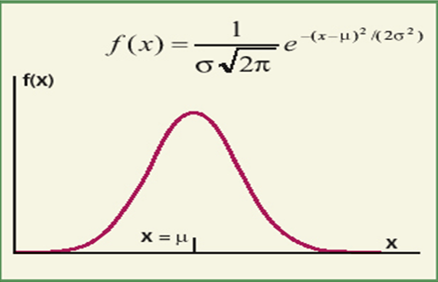
Fig. 1.7 Gaussian Noise
- Salt and Pepper noise
Salt and Pepper noise can be analytically described for an 8-bit image, the typical value for pepper noise is 0, and 255 for salt-noise. The salt-and-pepper type noise (also called impulse noise, shot noise or spike noise) is typically caused by malfunctioning pixel elements in the camera sensors, faulty memory locations, or timing errors in the digitization process as shown in Fig 1.8.

Examples of Uniform Noise and Salt-and-pepper Noise

Image with added uniform noise Image with added salt-and-pepper
Mean = 0 and variance = 600 noise with the probability of each 0.08
Fig 1.8 Uniform Noise and Salt-and-pepper Noise

1.6 Applications of Image Restoration
Applications in the field of image restoration are:
- The first application of digital image restoration in the engineering community was in the area of astronomical imaging. Extraterrestrial observations of the Earth and the planets were degraded by motion blur as a result of slow camera shutter speeds relative to rapid spacecraft motion. The astronomical imaging degradation problem is often characterized by Poisson noise, Gaussian noise etc.[3]

- In the area of medical imaging, image restoration has played a very important role. Restoration has been used for mammograms, filtering of Poisson distributed film-grain noise in chest X-rays and digital angiographic images, and for the removal of additive noise in Magnetic resonance Imaging.

- Another important application of restoration technique is to restore aging and deteriorated films. The motion picture restoration is often associated with digital techniques are used to eliminate scratches and dust from old movies and also to colorize black and white films. There has been significant work in the area of restoration of image sequences and well explained in literature.

- The expanding area of application for digital image restoration is that in the field of image and video coding. As techniques are developed to improve coding efficiency, and reduce the bit rates of coded images. Much has been accomplished to develop ways of restoring coded images as a post-processing step to be performed after decompression.

- Digital image recovery has also been used to restore blurred X-ray images of aircraft wings to improve aeronautical federal control procedures. It is for the recovery of the motion induced in the present frame or composite effects, and is generally used, restoring television images blurred uniformly.

CHAPTER 2
LITERATURE REVIEW
2.1 Spatial and Frequency Domain Filters for Restoring Noisy Images
(Vipin Tyagi, Paras Jain)[17]
The images are captured by various digital devices may be corrupted due to several reasons, e.g. motion blur, noise. Blurring often arises from the optical aberrations and motions between the object and the camera, and noise is caused by malfunctioning pixels in sensors of camera , inappropriate memory locations , or transmission onto a channel with noise. Blurring and noise distort any computer graphic algorithms aimed at the automatic recognition and identification of these images. Therefore, image restoration is a very important problem and is always an active research area . Image restoration is a process of reconstructing or recovering an image that has been degraded by using a priori knowledge of the degradation phenomenon. It usually involves formulating a criterion of goodness that will yield an optimal estimate of the desired result.

Image restoration is applicable in many areas like astronomical imaging as explained earlier. In the area of medical science imaging , image restoration is certainly a very important role. Restoration has also been used for filtering Poison distributed film grain noise in chest X-rays, mammograms, and digital images, and for removal of additive noise in Magnetic Resonance Imaging (MRI). Another emerging application of image restoration in medicine is in the area of QAR (quantitative autoradiography). In this field images are obtained by exposing X-ray sensitive film to a radioactive specimen.
Digital image restoration is being used in many other applications as well. Just to name a few, restoration has been used to restore blurry X-ray images of aircraft wings to improve the federal aviation inspection methods. It is used for restoring the motion induced effects present in still composite frames (produced by the superposition of two temporally fields of a video image), and, moreover for restoring uniformly blurred television pictures. Printing application often require the use of restoration to ensure that halftone reproductions of continuous images are of high quality. In addition to restoration can enhance the quality of continuous images generated from halftone images.
2.2 Adaptive edge-preserving image denoising using wavelet transforms
(Ricardo Dutra da Silva, Rodrigo Minetto)[2]

This paper presented an adaptive edge-preserving image denoising method in wavelet domain. A new thresholding scheme is proposed based on noise estimation on high frequency sub bands and edge strength. The choice of thresholding functions integrated with edge detection can improve the performance of denoising methods. Results indicated that the proposed method effectively suppresses Gaussian noise without smoothing important image details. Experiments demonstrated that the new method produces superior results compared to other methods based on the wavelet transform and results comparable to other state-of-the-art denoising methods.

The proposed method achieves similar results to all approaches considered in the comparison. However, when only wavelet-based approaches are considered, the proposed method achieves better results with PSNR and FOM and is similar to the Wienerchop method regarding the SSIM measure. Even though the proposed method is simple in nature, the results are comparable to those obtained with BM3D and superior to AD, TV, median and Wiener. Compared to BM3D, it is worth noticing that, although this method behaves well for lower noise ratios, it experiences a downfall at two higher noises. Differently, the proposed method presents a more linear trend.

In conventional thresholding schemes, a global (universal) threshold is commonly used to filtersmall wavelet coefficients However; this procedure can also remove high frequency components, such as edges. To improve the wavelet denoising method, an adaptive threshold is
calculated in a sub band-dependent manner to characterize local features of the image. A new thresholding scheme is proposed to threshold the small wavelet coefficients considered to be noise while preserving edges. This sub band-dependent thr8sholding is obtained based on the calculation of noise level and edge strength. The main stages of the proposed wavelet denoising method.

2.3 Wavelet-domain Image Restoration Model Based on Variation Regularization
(Caixia Li, Chanjuan Liu)[8]

There are two basic approaches to image denoising, spatial filtering methods and transform domain filtering methods. Spatial filters employ a low pass filtering on groups of pixels with the assumption that the noise occupies the higher region of frequency spectrum. Spatial Low-pass filters will not only smooth away noise but also blur edges in signals and images while the high-pass filters can make edges even sharper and improve the spatial resolution but will also amplify the noisy background.

Fourier transform domain filters used in signal and image processing involve a trade-off between the signal-to-noise ratio (SNR) and the spatial resolution of the signal/image processed. The conventional Fast Fourier Transform (FFT) based image denoising method is essentially a low pass filtering technique in which edge is not as sharp in the reconstruction as it was in the original. The edge information is spread across frequencies because of the FFT basis functions, which are not being localized in time or space. Hence low pass-filtering results in the smearing of the edges. But, the localized nature of the wavelet transforms both in time and space results in denoising with edge preservation.

Wavelet Analysis, a new form of signal analysis is far more efficient than Fourier analysis wherever a signal is dominated by transient behavior or discontinuities. Several investigations have been made into additive noise suppression in signals and images using wavelet transforms. Much of the early work on wavelet noise removal based on thresholding the Discrete Wavelet Transform (DWT) coefficients of an image and then reconstructing it, was done by Donoho and Johnstone. It has been found that wavelet based denoising is effective in that although noise is suppressed, edge features are retained without much damage.

Spatial Filtering - A traditional way to remove noise from image data is to employ spatial filters. Spatial filters can be further classified into non-linear and linear filters.

Non-Linear Filters - With non-linear filters, the noise is removed without any attempts to explicitly identify it.Spatial filters employ a low pass filtering on groups of pixels with the assumption that the noise occupies the higher region of frequency spectrum. Generally spatial filters remove noise to a reasonable extent but at the cost of blurring images which in turn makes the edges in pictures invisible. In this case, the value of an output pixel is determined by the median of the neighbourhood pixels, rather than the mean.

The most investigated domain in denoising using Wavelet Transform is the non-linear coefficient thresholding based methods. The procedure exploits sparsity property of the wavelet transform and the fact that the Wavelet Transform maps white noise in the signal domain to white noise in the transform domain. Thus, while signal energy becomes more concentrated into fewer coefficients in the transform domain, noise energy does not. It is this important principle that enables the separation of signal from noise. The procedure in which small coefficients are removed while others are left untouched is called Hard Thresholding. But the method generates spurious blips, better known as artifacts, in the images as a result of unsuccessful attempts of removing moderately large noise coefficients. In this scheme, coefficients above the threshold are shrunk by the absolute value of the threshold itself. Similar to soft thresholding, other techniques of applying thresholds are semisoft thresholding.

Undecimated Wavelet Transform (UDWT) has also been used for decomposing the signal to provide visually better solution. Since UDWT is shift invariant it avoids visual artifacts such as pseudo-Gibbs phenomenon. Though the improvement in results is much higher, use of UDWT adds a large overhead of computations thus making it less feasible. In normal hard/soft thresholding was extended to Shift Invariant Discrete Wavelet Transform. In Shift Invariant Wavelet Packet Decomposition (SIWPD) is exploited to obtain number of basis functions.

2.4 Adaptive Wavelet Thresholding for Image Denoising and Compression
(S. Grace Chang, Bin Yu, Martin Vetterli)[16]

The first part of this paper proposes an adaptive, data-driven threshold for image denoising via wavelet soft-thresh-olding. The threshold is derived in a Bayesian framework, and the prior used on the wavelet coefficients is the generalized Gaussian distribution (GGD) widely used in image processing applications. The proposed threshold is simple and closed-form, and it is adap-tive to each subband because it depends on data-driven estimates of the parameters. Experimental results show that the proposed method, called BayesShrink, is typically within 5% of the MSE of the best soft-thresholding benchmark with the image assumed known. It also outperforms Donoho and Johnstone’s SureShrink most of the time.

The second part of the paper attempts to further validate recent claims that lossy compression can be used for denoising. The BayesShrink threshold can aid in the parameter selection of a coder designed with the intention of denoising, and thus achieving simultaneous denoising and compression. Specifically, the zero-zone in the quantization step of compression is analogous to the threshold value in the thresholding function. The remaining coder design parameters are chosen based on a criterion derived from Rissanen’s minimum description length (MDL) principle. Experiments show that this compression method does indeed re-move noise significantly, especially for large noise power. However, it introduces quantization noise and should be used only if bitrate were an additional concern to denoising.

Two main issues regarding image denoising were addressed in this paper. Firstly, an adaptive threshold for wavelet thresh-olding images was proposed, based on the GGD modeling of subband coefficients, and test results showed excellent performance. Secondly, a coder was designed specifically for simultaneous compression and denoising. The proposed BayesShrink threshold specifies the zero-zone of the quantization step of this coder, and this zero-zone is the main agent in the coder which removes the noise. Although the setting in this paper was in the
Wavelet domain, the idea can be extended to other transform do-mains such as DCT, which also relies on the energy compaction and sparse representation properties to achieve good compression.

There are several interesting directions worth pursuing. The current compression selects the threshold (i.e. zero-zone size) and the quantization bin size in a two-stage process. In typical image coders, however, the zero-zone is chosen to be either the same size or twice the size as other bins. Thus it would be interesting to jointly select these two values and analyze their dependencies on each other. Furthermore, a more sophisticated coder is likely to produce better compressed images than the current scheme, which uses the first order entropy to code the bin indices. With an improved coder, an increase in the number of quantization bins would not increase the bitrate penalty by much, and thus the coefficients would be quantized at a finer resolution than the current method. Lastly, the model family could be expanded. For example, one could use a collection of wavelet bases for the wavelet decomposition, rather than using just one chosen wavelet, to allow possibly better representations of the signals

2.5 Denoising using Soft Thresholding
(D.L. Donoho)[10]
This paper presents a comparative study of different wavelet denoising techniques and the results obtained were examined. The denoising process rejects noise by thresholding in the wavelet domain. It is observed that „rigrsure„ method gives optimum performance. Discrete wavelet transform has the benefit of giving a joint time frequency representation of the signal. Also it is suitable for both stationary and non stationary signals and is the mos appropriate system in the field of signal detection. Discrete wavelet transform is implemented through multi resolution analysis and digital filter banks.

Wavelets are functions that satisfy certain mathematical requirements and are used in representing data or other functions. Algorithms process data at different scales or resolutions. If we look at a signal (or a function) through a large “window,” we would notice gross features. Similarly, if we gaze at a signal through a small “window,” we would notice small features. The result in wavelet analysis is to see both the forest and the trees together. This makes study of wavelets interesting and useful. The data sets of many scientific experiments are corrupted with noise, either because of the data acquisition process, or because of environmental effects. A first pre-processing step in analyzing such datasets is denoising, that is, estimating the unknown signal of interest from the available noisy data. There are several different approaches to denoise signals and images. Despite similar visual effects, there are subtle differences between denoising, de-blurring, smoothing and restoration.

Generally smoothing removes high frequency and retains low frequency (with blurring). De-blurring increases the sharpness signal features by boosting the high frequencies, whereas denoising tries to remove whatever noise is present regardless of the spectral content of a noisy signal .Restoration is a kind of denoising that tries to retrieve the original signal with optimal balancing of de-blurring and smoothing Wavelet transforms enable us to represent signals with a high degree of sparsity. This is the principle behind a non-linear wavelet based signal estimation technique known as wavelet denoising. Wavelet denoising attempts to remove the noise present in the signal while preserving the signal characteristics, regardless of its frequency content. Wavelet denoising must not be confused with smoothing. As already mentioned smoothing only removes the high frequencies and retains the lower ones.

Computational competence makes wavelet scheme attractive. The major observation from the set of experiments is that rigrsure gives best performance. It is observed that performance of minimax & heursure is better than that of sqtwolog. Denoising performance varies with type of signal under considerations and wavelet chosen.

CHAPTER 3
IMAGE DENOISING

Image denoising [10] is a relevant issue found in diverse image processing and computer vision problems. It is a challenge to preserve important features, such as edges, corners and other sharp structures, during the denoising process. Wavelet transforms have been widely used for image denoising since they provide a suitable basis for separating noisy signal from the image signal. This paper describes a novel image denoising method based on wavelet transforms to preserve edges. An adaptive thresholding scheme based on edge strength is used to effectively reduce noise while preserving important features of the original image. Experimental results, compared to other approaches, demonstrate that the proposed method is suitable for different classes of images contaminated by Gaussian noise.

Digital images can be corrupted by noise during the process of acquisition and transmission, degrading their quality. A major challenge is to remove as much as possible of the noise without eliminating the most representative characteristics of the image, such as edges, corners and other sharp structures. These filters usually smooth the data to reduce noise effects; however, this process can cause image blurring or edge removal.

The common idea related to the suppression of noise based on the wavelet transform is to compute the wavelet decomposition of the noisy image and to manipulate the obtained wavelet coefficients. Reconstruction from these manipulated coefficients then generates the resulting denoised image. Here is an example shown in Fig 3.1.
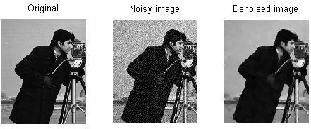
Fig 3.1 Image Denoising
3.1 Image denoising by wavelet thresholding
Wavelet thresholding is a common approach for denoising due to its simplicity. There are several studies on thresholding the wavelet coefficients[6]. The process, commonly called wavelet shrinkage, consists of the following main stages:
1. Perform the discrete wavelet transform;
2. Estimate a threshold;
3. Apply the threshold according to a shrinkage rule;
4. Perform the inverse wavelet transform using the threshold coefficients.
Suppose that a given image f = {$f_{xy}$ , x = 1….M, y = 1… N} has been corrupted by additive noise according to the following model

g = f + n (3.1)

Where in Equation (3.1) n represents the noise and g the observed image. A common assumption is that the noise is statistically independent and identically distributed. Most of the existing methods are designed for the case of additive white Gaussian noise.
The decomposition of the image g into coefficients through a discrete wavelet transform W can be expressed as in Equation 3.2.

G = W(g) (3.2)

The application of the discrete wavelet transform decomposes the input image into different frequency subbands, labeled as LL_{j}, LH_{k}, HL_{k} and HH_{k}, k =1, 2, …, J, where the subscript indicates the k-th resolution level of wavelet transform and J is the largest scale in the decomposition. These subbands contain different information about the image. The LH_{k}, HL_{k} and HH_{k} subbands correspond to horizontal, vertical and diagonal details of the image signal, respectively. The highest frequency HH₁ subband can contain a significant amount ofnoise. The LL_{k-1} subband can be further recursively decomposed to form the LH_{k}, HL_{k} and HH_{k} subbands[2].

After the selection of a threshold, the wavelet coefficients are modified according to a shrinkage function T, such that

$\hat{F}=T(G)$ (3.3)

The last step in the wavelet shrinkage is to transform the thresholded coefficients back to the original domain, expressed as

$\hat{f}=W^{-1}(\hat{F})$ (3.4)

Where in Equation 3.4 $W^{-1}$ denotes the inverse discrete wavelet transform and $\hat{f}$ is the denoised image.

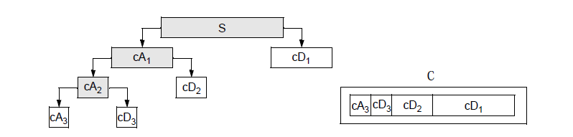

Fig. 3.2 Multilevel Wavelet Decomposition of a Signal

Fig. 3.3 Wavelet Decomposition of Image

Fig. 3.4 Wavelet decomposition of degraded image

3.2 The Selection of Wavelet

Because wavelet basis function has different categories and each category has different properties, so the selection of wavelet basis function depends on the following aspects[8]:

- Orthogonality

Firstly, Orthogonality allows the L2 norm of the function f to directly establish relation with the norm of its wavelet coefficients. Secondly, the fast wavelet transform is a unitary transform, and its inverse transform is easy to implement. Finally, it has the advantage of good computational stability; high precision and fine signal energy maintain ability.

- Symmetry

If both the scaling function and wavelet function are symmetric, the filter will produce linear phase. Linear phase is not only suitable for human visual system, but also easy to handle the signal edge.

- Compact Support

Compact support is an important property of wavelet. The smaller wavelet support set is, the stronger its localization ability is, which makes it is more beneficial to determine the signal mutations. The correspondence filter of compactly supported wavelet is a finite impulse response (FIR) filter, so the sum of the corresponding fast wavelet transform is limited

- Regularity

Regularity is a description of the function smoothness degree; it is also a measure of energy concentration. Take the Daubechies wavelets and spline wavelets for example, smoothness increases with the increase of support set length, but the increase of support set length will extend the processing time.

- High Order Vanishing Moments

Vanishing moment of the wavelet transform shows the degree of energy concentration. When the order of vanishing moments is large, under the fine-scale, some values of high frequency part are small enough to be negligible (except the singular point). Table 3.2 shows several performances of common wavelet. We know that different images have different features, similarly, different wavelet bases also express different features when analyzing and reconstructing images. Essentially, the performances of wavelet based signal processing method firstly depend on inherent features of the signal; secondly, it depends on the selection of processing method. Once the signal to be processed has been selected, the most important thing is the choice of wavelet basis.

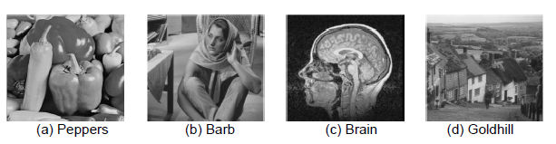
In order to verify different wavelet basis function on the result of image processing, we choose cartoon effect image Peppers, containing textures image Barb, medical image Brain and natural landscape image Goldhill, noise with $σ^{2}=20$ was added to these images, different wavelets were selected for experiment, Peak signal to noise (PSNR) and Mean absolute error (MAE) are as follows in Table 3.1

Fig. 3.5 Selected Wavelet
 | Haar | Bior2.4 | Db4 | Sym4
Peppers | 29.9610 | 29.7044 | 29.8331 | 29.9894
Barb | 28.7833 | 28.7082 | 28.8620 | 28.8428
Brain | 28.5693 | 28.5176 | 28.9880 | 29.0013
GoldHill | 28.5557 | 28.3603 | 28.5904 | 28.6067

Table 3.1 Comparison Results of Selected Wavelet (PSNR)

Wavelet  Function | Haar | Daubechies | Biorthogonal | Symlets
representation | Haar | dbN | biorNr.Nd | symN
orthogonality | Has | Has | No | Has
biorthogonality | Has | Has | Has | Has
Compact support | Has | Has | Has | Has
Length compact support | 1 | 2N-1 | re: 2Nr+1  de: 2Nd+1 | 2N-1
Length of filter | 2 | 2N | Max(2Nr+2Nd)  +2 | 2N
symmetry | S | App S | S | App S
Table 3.2 Several Common Wavelets Application Performance Analysis Wavelet function Haar

3.3 Threshold estimation
Three threshold estimation criteria, called VisuShrink, SureShrink and BayesShrink, are described as follows[9].

- VisuShrink
It is a thresholding scheme that uses a single universal threshold, defined as in Equation (3.5). L = M * N is the number of pixels in the image. The same threshold is applied to all levels of decomposition. Although the resulting estimate is very smooth and has a pleasant visual appearance, it is known that VisuShrink tends to over smooth the signal.

${ λ}_{V} =σ_{ noise}\sqrt{2logL}$ (3.5)

- SureShrink
It is a thresholding scheme that applies a sub band adaptive threshold. A separate threshold is computed for each sub band based on Stein’s unbiased risk estimator (SURE) as shown in Equation (3.6) where $G_{s}$is the detail coefficients from sub band S and N_{S} is the number coefficient Gxy in {G_{S}} .When the coefficients are not very sparse, SureShrink is applied; if not, universal threshold is applied.

${ λ}_{s}={argmin}_{t≥0 }$SURE (t,$G_{S}$) (3.6)

- BayesShrink
Uses a Bayesian mathematical framework and assumes generalized Gaussian distribution for the wavelet coefficients in each detail sub band to find the threshold that minimizes the Bayesian risk, expressed as in Equation (3.7) previous equations, most thresholding algorithms require an estimate of the noise variance. For images, the noise level can be estimated from the highest frequency coefficients.
${ λ}_{B}=\frac{{σ_{noise}}^{2}}{σ_{signal}}$ (3.7)
A robust estimate of noise variance uses the median absolute value of the wavelet coefficients which is insensitive to isolated outliers of potentially high amplitudes, defined as in Equation (3.8) where G_{xy} are the HH wavelet coefficients that form the finest decomposition level. It is assumed that the noise follows a Gaussian distribution with zero mean and variance$σ^{2}$.

${ σ}_{noise}=\frac{median(\left|G_{xy}\right|)}{0.6754}$ , $G_{xy} ϵ subband HH$ (3.8)

3.3.1 Shrinkage rules

The shrinkage rule[13] defines how the threshold must be applied. In its basic form, each coefficient in the wavelet transform domain is compared against a threshold. If the coefficient is smaller than the threshold, it is assigned zero otherwise, it is kept or modified. The motivation is that large coefficients are due to important signal features, while small coefficients can be thresholded without affecting the significant features of the image. One of the first works that describe such an approach was reported by Weaver et al. Donoho and Johnstone developed a systematic theory for wavelet thresholding. Jansen and Antoniadis extensively reviewed wavelet thresholding techniques for image noise reduction. In the shrinkage rule known as hard thresholding, the coefficients w = G_{xy} that are less than or equal to the threshold $λ$ are set to zero, while the remaining coefficients are left unchanged as shown in Equation (3.9)

W, if |w|> λ
$${ T}_{hard}(w)=$$
0, if |w|≤ λ (3.9)

In soft thresholding, as shown in Equation (3.10) the wavelet coefficients above the threshold are reduced by an amount equal to the value of the threshold where sgn(x) function returns the sign of the parameter x and (a)₊ is defined in Equation (3.11)

$sgn\left(w\right){(\left|w\right|-λ)}_{+}$ if |w|>λ
$T_{soft}(w)=$
0 if |w|≤ λ (3.10)

0 if a<0
$${ (a)}_{+}=$$
a if a≥ 0 (3.11)

A disadvantage of the hard thresholding is its abrupt discontinuity, which may cause artifacts in the reconstructed image. On the other hand, the soft thresholding tends to oversmooth the reconstructed image.
Other thresholding schemes (Equation (3.12) have been proposed, which are a compromise between the two previous approaches. The hyperbola function is continuous and attenuates large coefficients less than soft thresholding

sgn(w)$\sqrt{w^{2}-λ^{2}}$ if |w|>λ
$${ T}_{hyper}(w)=$$
0 if |w| ≤ λ (3.12)

Gao et al. proposed the firm thresholding to avoid the drawbacks of both hard and soft thresholding rules, providing less sensitivity to small perturbations in the data and smaller overall mean-squared error as specified in Equation 3.13

w if |w|>$λ_{2}$
${ T}_{firm}(w)=$ sgn(w)$\frac{λ_{2}(\left|w\right|-λ_{2})}{λ_{1}-λ_{2}}$ if $λ_{1}<|w|≤λ_{2}$
0 if |w| ≤ $λ_{1}$ (3.13)

The firm thresholding requires two threshold values, $λ_{1}$ and $λ_{2}$, making the estimation procedure more computationally expensive. To overcome this drawback, Gao et al. proposed the nonnegative garrote thresholding which offers advantages over hard and soft thresholding and is comparable to the firm thresholding, while requiring only one threshold value.(as shown in Equation (3.14)

$w-\frac{λ^{2}}{w}$ if |w| >λ
${ T}_{garrote}(w)=$
0 if |w| ≤ λ (3.14)

Antoniadis and Fan suggested the SCAD thresholding rule, defined as in Equation (3.15)

W if |w|>αλ

${ T}_{SCAD}(w)=$ $\frac{\left(α-1\right)w-αλsgn(w)}{α-2}$ if 2λ<|w|≤αλ

Sgn(w) max(0,|w|-λ) if |w|≤2λ (3.15)

3.3.2 Hard Thresholding
To suppress the noise we apply the nonlinear transform mentioned in Equation (3.16) to the empirical wavelet coefficients, where t is a certain threshold[12]. The choice of the threshold is a very delicate and important statistical problem as shown in Fig 3.6
$F\left(x\right)=x.I (\left|x\right|>t)$ (3.16)
On the one hand, a big threshold leads to a large bias of the estimator. But on the other hand, a small threshold increases the variance of the smoother. Theoretical considerations yield the following value of the threshold as mentioned in Equation (3.16), where ‘n’ is the length of the input vector and $σ^{2}$ is the variance of the noise. The variance of the noise is estimated based on the data. We do this by averaging the squares of the empirical wavelet coefficients at the highest resolution scale.
$t=\sqrt{{2log⁡(n)σ^{2}}/n}$ (3.17)
We provide two possibilities for choosing a threshold. First of all you can do it by “eye”' using the Hard threshold item and entering the desired value of the threshold. The threshold offered is the one described in the paragraph before. Note that this threshold value is in most cases conservative and therefore we should choose a threshold value below the offered one. The item Automatic means that the threshold will be chosen as $\sqrt{{2log⁡(n)σ^{2}}/n}$

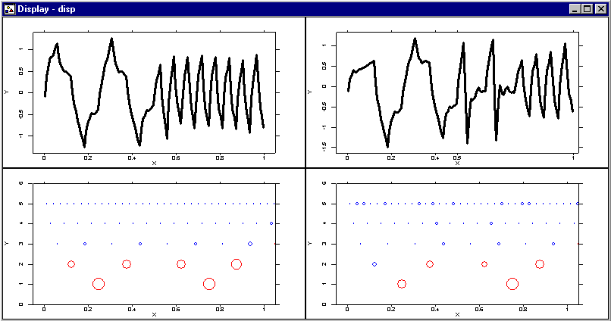

Fig 3.6 Plot of Hard thresholding

3.3.3 Soft Thresholding
Along with hard thresholding in many statistical applications soft thresholding procedures are often used. In this section, we study the so-called wavelet shrinkage procedure for recovering the regression function from noisy data as shown in Fig 3.7[11].
The only difference between the hard and the soft thresholding procedures are in the choice of the nonlinear transform on the empirical wavelet coefficients. For soft thresholding the following nonlinear transform as used in Equation (3.18), where t is a threshold. The menu provides you with all possibilities for choosing the threshold and exploring the data. In addition you can use a data driven procedure for choosing the threshold. This procedure is based on Stein's principle of unbiased risk estimation. The main idea of this procedure is the following. Since S(x) is a continuous function, given t, one can obtain an unbiased risk estimate for the soft thresholding procedure. Then the optimal threshold is obtained by minimization of the estimated risks.
$S(x)=sign\left(x\right)\left(\left|x\right|-t\right)I(\left|x\right|>t$) (3.18)

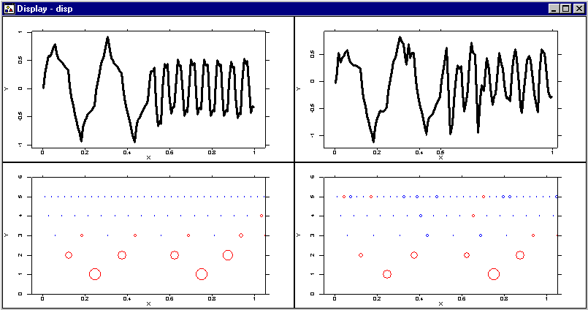

Fig 3.7 Plot for Soft Thresholding

3.3.4 Thresholding Methodologies

The choice of threshold is a fundamental issue. A very large threshold cuts too many coefficients, resulting in an over smoothing. Conversely, a too small threshold value allows many coefficients to be included in reconstruction, giving a wiggly, under smoothed estimate. The proper choice of threshold involves a careful balance of these principles. Most of the work is mainly due to Donoho and Johnstone[10].
A variety of threshold choosing methods can be mainly divided into two categories:

- Global thresholding
- Level−dependent thresholding.

The former chooses a single value to be applied globally to all empirical wavelet coefficients, while the later chooses different threshold value j for each wavelet level j.

A). Universal Thresholding (‘sqtwolog’)

This type of global thresholding method was proposed by Donoho and Johnstone. This is also called “sqtwolog” method. The threshold value is given in Equation (3.19) where n is the number of data points, and $λ$ is an estimate of the noise level σ. Donoho and Johnstone proposed an estimate of σ that is based only on the empirical wavelet coefficients at the highest resolution level LL₁ because they consist most of noise.

$λ=σ\sqrt{2\log{n}}$ (3.19)

Most of the function information except the finest details is in lower level coefficients. The Median of absolute deviation (MAD) estimator is expressed in Equation (3.20). The universal thresholding removes the noise efficiently. The fitted regression curve is often very smooth and hence visually appealing.

$\frac{median(\left|w_{j-1,k}-median\left(w_{j-1,k}\right)\right|)}{0.6475}$ (3.20)

If z₁…..z_{n} represents the wavelet coefficients of the noise with idd N (0, σ2), then it is expressed in Equation (3.21)

$\lim_{n→∞}{P\left(z_{i}≤ σ\sqrt{2\log{n}}\right)=1}$ (3.21)

This means that the probability of all noise being shrunk to zero is very high for large samples. Since the universal thresholding procedure is based on this asymptotic result, it sometimes does not perform well in small sample situations.

B) ‘Heursure’ method
SureShrink does not perform well in certain cases that the wavelet representation at any level is very sparse, i.e., when the vast majority of coefficients are essentially zeros. Thus, Donoho suggest a mixture of universal threshold and SureShrink. If the set of coefficients is sparse, then the universal threshold is used; otherwise, SURE is applied. We call this hybrid method as Heursure.

3.4 Image Denoising Method
Image denoising[5] is a common procedure in digital image processing aiming at the removal of noise which may corrupt an image during its acquisition or transmission while sustaining its quality as shown in Fig 3.8. This paper presents a review of some significant work in the area of image denoising. After a brief introduction, some popular approaches are classified into different groups and an overview of various algorithms and analysis is provided.

In conventional thresholding schemes, a global (universal) threshold is commonly used to filter small wavelet coefficients. However, this procedure can also remove high frequency components, such as edges. To improve the wavelet denoising method, an adaptive threshold is calculated in a sub band-dependent manner to characterize local features of the image. A new thresholding scheme is proposed to threshold the small wavelet coefficients considered to be noise while preserving edges. This sub band-dependent thresholding is obtained based on the calculation of noise level and edge strength. Initially, the input image, in Fig 3.9 corrupted by Gaussian noise, is partitioned into m x m pixel blocks. Blocks are used in a manner such that the denoising algorithm can exploit local noise characteristics and adapt thresholding to produce better results. Nevertheless, as information is often lost due to the thresholding, blocking effects between boundaries of neighbor blocks often arise. A larger region Bn of size n x n pixels (n>m), encompassing an m x m block Bm, is used to avoid such undesirable effects. The discrete wavelet transform is then applied to each block Bn.

Obtaining Sampling Sequence

Estimating the Standard Deviation

Applying Continuous Wavelet Transform

Calculate the Noise Level

Fig. 3.8 Image Denoising Method

Image Decomposition into blocks
Wavelet transform W

W
Noisy image

Threshold estimation
Edge Detection

Shrinkage Rule
Inverse wavelet transform
Denoised Image

Fig. 3.9 Diagram of the Proposed Denoising method

Fig. 3.10 Classification of Denoising Techniques

CHAPTER 4
PROPOSED METHODOLOGY

4.1 Adaptive Thresholding Function
In this section focuses on the estimation of the GGD parameters, which in turn yields a data-driven estimate of that is adaptive to different sub band characteristics. The noise variance needs to be estimate first. In some situations, it may be possible to measure based on information other than the corrupted image. If such is not the case, it is estimated from the sub band by the healthy median estimator. As given in Equation (4.1) where Yij € sub band HH1.

$σ={median(\left|Y_{ij }\right|)}/{0.6745}$ (4.1)

The parameter does not explicitly enter into the expression TB (σ_{x}) of, only the signal standard deviation (σ_{x}). T_{B} is the optimal threshold function. Therefore it suffices to estimate directly σ_{x} or σ_{x2}.Recall the observation model is Y = X + U, with X and U independent of each other,
Where n x n is the size of the sub band under consideration. As given below in Equation (4.2)

$T_{B}^{^}(σ_{x })=\frac{σ^{2}}{σ^{x}}$ (4.2)

Where:

$$σ_{y}^{2}=σ_{x}^{2}+σ^{2}$$

$$σ_{x}^{^}=\sqrt{max⁡(σ_{y}^{2}-σ^{2} ,0)}$$
Where${ σ}_{y}^{2}$ is the variance of Y. Since Y is modelled as zero-mean, ${ σ}_{y}^{2}$ can be found empirically as stated per Equation (4.3) and (4.4)

$σ_{y}^{2}=\frac{1}{n^{2}}\sum_{i,j=1}^{n}{{{(X}_{ij}}^{2})}$ (4.3)

$T_{B}^{^}\left(σ_{x}\right)=max⁡(|y_{ij}$|) (4.4)

The above equation Equation (4.3) and (4.4) shows the probalistics function which is proposed by scientist bayes .so, this method is called as B Wavelet Thresholding Bayesian shrink. And below Equation (4.5) shows the optimal threshold.

$T_{B}^{^}(σ_{x})=\frac{σ^{2}}{σ^{x}}$ (4.5)

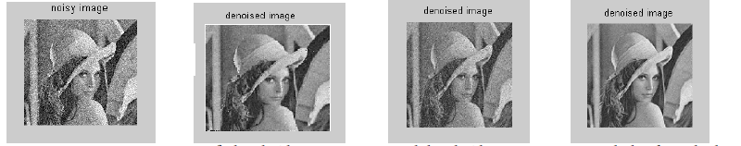
- (b) (c) (d)
Fig 4.1. Comparing the performance of (a) Noisy Lena at σ = 30 with (b) soft thresholding
(c) Hard thresholding (d) proposed Shrink method

Start
Original Image

Addition of Noise

Wavelet Thresholding

Denoised Image
Stop

Fig 4.2 Flow Chart of the Algorithm

The main issues regarding image denoising is addressed . An adaptive threshold for wavelet thresholding images was proposed, based on the generalized Gaussian Distribution modeling of sub band coefficients, and test results showed excellent performance.The results show that Proposed Shrink removes noise significantly. We compare the results with soft thresholding, hard thresholding & proposed method

4.2 Implementation -Wavelet Denoising
The performance of four conventional denoising algorithms – namely “rigrsure”, “heursure”, “sqtwolog” and “minimax” is compared .The denoising procedure is explained in the flow chart shown in Fig 4.3.

Fig 4.3 Flow Chart for Wavelet Denoising

With the four methods, denoising is done. Type of thresholding used is soft thresholding. Denoised signal‟s performance is compared based on mean square error computed. This is implemented using Matlab tool box, which is widely used for high performance numerical computation and visualization The wavelet used is db4. Ingrid Daubechies
invented what are called compactly supported orthonormal wavelets, thus making discrete wavelet analysis practicable. Daubechies wavelets are the most popular wavelets. They represent the foundations of wavelet signal processing and are used in numerous applications. The names of the Daubechies family wavelets are written dbN, where N is the order,and db the "surname" of the wavelets.

4.3 Proposed Algorithm
Input: Degraded-image

Output: Restored-image

Procedure:

Step1: Read the image g and perform the digitization.

Step2: Convert the image into matrix of m x n such that each pixel value represents a matrix element A_{mn.}

Step3: Perform the Wavelet transform W on image g

G = W(g)

the discrete wavelet transform decomposes the input image into different frequency
subbands, labeled as LL_{j}, LH_{k}, HL_{k} and HH_{k}, k =1, 2, …, J

Step4: Apply the edge detection on G
$\left|G\right|=\sqrt{{\left(\frac{∂I}{∂i}\right)}^{2}+{\left(\frac{∂I}{∂j}\right)}^{2} or }\left|G\right|=\sqrt{{G_{i}}^{2}+{G_{j}}^{2}}$

Step5: Selection of Threshold on HH_{i} subband.
$σ={median(\left|G_{ij }\right|)}/{0.6745}$ $T_{B}^{^}(σ_{x })=\frac{σ^{2}}{σ^{x}}$
Step 6 : Repeat Step 5 until number of iterations becomes equal to number of decomposition levels.
Step 7: Apply the threshold according to the shrinkage rule.
Step 8: Repeat Step 7 until number of iterations becomes equal to number of decomposition levels.
Step 9 : Perform the inverse wavelet transform using threshold coefficients.
End

4.4 Technologies Used

4.4.1 MATLAB
MATLAB (matrix laboratory) is a fourth-generation high-level programming language and interactive environment for numerical computation, visualization and programming. MATLAB is developed by Math Works.
It allows matrix manipulations; plotting of functions and data; implementation of algorithms; creation of user interfaces; interfacing with programs written in other languages, including C, C++, Java, and FORTRAN; analyze data; develop algorithms; and create models and applications. It has numerous built-in commands and math functions that help you in mathematical calculations, generating plots and performing numerical methods.

4.4.2 Image Processing Toolbox
Image Processing Toolbox provides a comprehensive set of reference-standard algorithms, functions, and apps for image processing, analysis, visualization, and algorithm development. You can perform image analysis, image segmentation, image enhancement, noise reduction, geometric transformations, and image registration. Many toolbox functions support multicourse processors, GPUs, and C-code generation.

Image Processing Toolbox supports a diverse set of image types, including high dynamic range, gigapixel resolution, embedded ICC profile, and topographic. Visualization functions and apps let you explore images and videos, examine a region of pixels, adjust color and contrast, create contours or histograms, and manipulate regions of interest (ROIs). The toolbox supports workflows for processing, displaying, and navigating large images.

4.4.3. System Requirements
Hardware Requirements
- A minimum of 300Mhz processor
- A minimum of 64 Mb RAM
- No strict specification about the hard disk.

Software Requirements
- Windows 9812000/Platform
- MATLAB
- An image file

CHAPTER 5
EXPERIMENTAL RESULTS

The methods are compared using 4 different parameters which are as follows :
1. PSNR value
2. Mean Squared Error
3. SNR value
4. Root Mean Squared Error

Here in the Table 5.1 we have compared the different wavelet threshold estimation techniques found in wavelet transform with respect to soft thresholding. We can see in the given thresholding techniques that bayes thresholding estimation provides the better results.
Table 5.1 Comparison Parameters for Soft Thresholding
S.No | Comparison Parameters | Visu Shrink | Sure Shrink | Bayes Shrink
1 | PSNR | 27.98 dB | 29.89 dB | 33.72 dB
2 | MSE | 0.421 | 0.387 | 0.146
3 | SNR | 33.40 dB | 31.86 dB | 34.01 dB
4 | RMSE | 0.64 | 0.62 | 0.38

Here in the Table 5.2 we have compared the different wavelet threshold estimation techniques found in wavelet transform with respect to hard thresholding. We can see in the given thresholding techniques that bayes thresholding estimation provides the better results.
Table 5.2 Comparison Parameters for Hard Thresholding
S.No | Comparison Parameters | Visu Shrink | Sure Shrink | Bayes Shrink
1 | PSNR | 26.876 dB | 28.672 dB | 31.17 dB
2 | MSE | 0.645 | 0.47 | 0.20
3 | SNR | 30.157 dB | 30.016 dB | 33.12 dB
4 | RMSE | 0.803 | 0.68 | 0.61

After the comparison of various thresholding techniques with respect to hard and soft thresholding methods. We can see from table 5.1 and table 5.2 that the soft thresholding method provides the better results.

Result of Proposed Algorithm
We have implemented our proposed algorithm on different wavelet families and compared using above four parameters. Different wavelet families include Haar, Db4 , Db2 . We have also implemented our algorithm on different decomposition levels and we can conclude from Table 5.3 that the Algorithm provides the expected results.
Table 5.3 Result of Proposed Algorithm for different Wavelets
S.No | Comparison Parameters | Haar | Db4 | Db2
1 | PSNR | 38.08 dB | 36.156 dB | 36.562 dB
2 | MSE | 0.004 | 0.034 | 0.028
3 | SNR | 37.86 dB | 35.42 dB | 34.874 dB
4 | RMSE | 0.06 | 0.18 | 0.16

CHAPTER 6
CONCLUSION AND FUTURE EXTENSION

6.1 Conclusion
So we conclude the following about image restoration. The purpose of image restoration is to "compensate for" or "undo" defects which degrade an image. Degradation comes in many forms such as motion blur, noise, and camera misfocus. . In cases like motion blur, it is possible to come up with a very good estimate of the actual blurring function and "undo" the blur to restore the original image. In cases where the image is corrupted by noise, the best we may hope to do is to compensate for the degradation it caused. In this project, we introduced and implemented several of the methods used in the image processing world to restore images. This report tried to show the methods and importance of image processing. One of the image processing techniques, the digital image restoration, is discussed and the methods on how to apply are briefly explained. Digital image restoration is an important field that is used in different scientific researches and technology developments.

6.2 Future Extensions
Some of the limitations of the proposed system and future scope to resolve these limitations are given as follows.

- The future work to be done is better implementation of various techniques which will improve the quality of output image and improve the integrity of the overall restoration technique.
- We’ll try to build a model to achieve highest PSNR values and lowest MSE values.

APPENDIX A – PROJECT CODE

Code C1 : denoised_demo, The main program which invokes the denoise_image function.

clc; clf; clear all;close all;

img = imread('coins.png');
im = double(img)/255;
figure,imshow(im,[]),
title('Original Glasses Image');
sigma = 30;

img = double(img)+sigma*randn(size(img));
imn = img/255; sigma = sigma/255;
PSNR_0 = psnr(im,imn);
figure,

imshow(imn,[],'Border','loose'),
title(['Noisy: PSNR = ' num2str(PSNR_0,'%.2f') ' dB'],'fontsize',10,...
'fontweight','bold');

[m n]=size(imn);
T0= sqrt(2*log(m*n))*sigma*0.68;
options=struct('name',{'bayes'},'params',{struct('incd',0,'wnam','db4','decl',3)});

tic;
denoised_image=denoise_image(imn,options,sigma,'m',1,im,1);
toc

Code C2 :denoised_image
function denoise_image = denoise_image(imn, options, sigma, errtype, plot, im, dna)

0if nargin < 2
display('imn and options argument are necessary, Please see help');
end
if nargin < 3
sigma = find_sigma(imn);
end

type = 'null';
switch errtype
case 'm', errname = 'MSE';
case 'p', errname = 'PSNR';
case 'a', errname = 'ABS';
case 's', errname = 'SNR';
otherwise, display('Unknown method, see help');
end

denoise_image = [];
[t,NumMethods] = size(options);
wnam_old = 'null';
decl_old = 0;
figcnt = 0;

for method = 1:NumMethods
params = options(method).params;
switch lower(options(method).name)

%% Universal Threshold method
case 'visu'
if (~isfield(params,'incd')), incd = 0;
else incd = params.incd; end
if (~isfield(params,'type')), type = 'soft';
else type = params.type; end
if (~isfield(params,'wnam')), wnam = 'db8';
else wnam = params.wnam; end
if (~isfield(params,'decl')), decl = 4;
else decl = params.decl; end

if (~strcmp(wnam_old,wnam) || decl_old ~= decl)
if (strcmp(wnam,'tetr'))
[C,L,B] = tetrom2(imn,decl);
else
[C,L] = wavedec2(imn,decl,wnam);
end
wnam_old = wnam;
decl_old = decl;
end

% Wavelet thresholding
if (strcmp(type,'hard'))
opt.type = 'visu_hard';
else
opt.type = 'visu_soft';
end
opt.incd = incd;
opt.sigma = sigma;
CT = perform_wavelet_thresholding(C,L,opt);
clear opt;

% Reconstruct the image
if (strcmp(wnam,'tetr'))
im_hat = invtetrom2(CT,L,B);
else
im_hat = waverec2(CT,L,wnam);
end

if (~strcmp(im,'null'))
err = calculate_error(im,im_hat,errtype);
end
denoise_image = [denoise_image; collect_image_statistics(im,im_hat)];

% Plot the image
fname = strcat(lower(options(method).name),'-',type);
if (plot)
figure,
imshow(im_hat,[],'Border','loose'),
title([wnam,' Universal thresholding (', type,') with ', errname, ' = ' num2str(err,'%.2f') ' dB'],'fontsize',10,...
'fontweight','bold');
end

%% sure Threshold method

case 'sure'

if (~isfield(params,'incd')), incd = 0;
else incd = params.incd; end
if (~isfield(params,'wnam')), wnam = 'db8';
else wnam = params.wnam; end
if (~isfield(params,'decl')), decl = 4;
else decl = params.decl; end

if (~strcmp(wnam_old,wnam) || decl_old ~= decl)
if (strcmp(wnam,'tetr'))
[C,L,B] = tetrom2(imn,decl);
else
[C,L] = wavedec2(imn,decl,wnam);
end
wnam_old = wnam;
decl_old = decl;
end

% Wavelet thresholding
opt.type = 'sure';
opt.incd = incd;
opt.sigma = sigma;
CT = perform_wavelet_thresholding(C,L,opt);
clear opt;

% Reconstruct the image
if (strcmp(wnam,'tetr'))
im_hat = invtetrom2(CT,L,B);
else
im_hat = waverec2(CT,L,wnam);
end

if (~strcmp(im,'null'))
err = calculate_error(im,im_hat,errtype);
end
denoise_image = [denoise_image; collect_image_statistics(im,im_hat)];

fname = strcat(lower(options(method).name),'-');
if (plot)
figure,
imshow(im_hat,[],'Border','loose'),
title([wnam,' Sure thresholding with ', errname, ' = ' num2str(err,'%.2f') ' dB'],'fontsize',10,...
'fontweight','bold');
end

if (dna)
t = strcat(fname,'method noise');
method_noise(im, im_hat, t);
end

%% Bayes Threshold method

case 'bayes'
% Parse the parameters
if (~isfield(params,'incd')), incd = 0;
else incd = params.incd; end
if (~isfield(params,'wnam')), wnam = 'db8';
else wnam = params.wnam; end
if (~isfield(params,'decl')), decl = 4;
else decl = params.decl; end

% decompose the image if necessary
if (~strcmp(wnam_old,wnam) || decl_old ~= decl)
if (strcmp(wnam,'tetr'))
[C,L,B] = tetrom2(imn,decl);
else
[C,L] = wavedec2(imn,decl,wnam);
end
wnam_old = wnam;
decl_old = decl;
end

% Wavelet thresholding
opt.type = 'bayes';
opt.incd = incd;
opt.sigma = sigma;
CT = perform_wavelet_thresholding(C,L,opt);
clear opt;

% Reconstruct the image
if (strcmp(wnam,'tetr'))
im_hat = invtetrom2(CT,L,B);
else
im_hat = waverec2(CT,L,wnam);
end

% calculate error if original image is given
if (~strcmp(im,'null'))
err = calculate_error(im,im_hat,errtype);
end
denoise_image = [denoise_image; collect_image_statistics(im,im_hat)];

% Plot the image
fname = strcat(lower(options(method).name),'-');

if (plot)
figure,
imshow(im_hat,[],'Border','loose'),
title([wnam,' Bayes thresholding with ', errname, ' = ' num2str(err,'%.2f') ' dB'],'fontsize',10,...
'fontweight','bold');
end

if (dna)
t = strcat(fname,'method noise');
method_noise(im, im_hat, t);
end

Code C3 :Bayes Thresholding function
function thre = BayesThres(y,sigma)

n = length(y);
y = y - mean(y);
sigmaYSquare = (1/n)*sum(y.^2);
sigmaS = sqrt(max((sigmaYSquare-sigma^2),0));

if sigmaS == 0
sigmaS = max(y(:));
end

thre = sigma^2/sigmaS;
Code C4 :Soft Thresholding function

function x = SoftThresh(y,t)
% SoftThresh -- Apply Soft Threshold
% Usage
% x = SoftThresh(y,t)
% Inputs
% y Noisy Data
% t Threshold
% Outputs
% x sign(y)(|y|-t)_+
%
res = (abs(y) - t);
res = (res + abs(res))/2;
x = sign(y).*res;

APPENDIX B – SCREENSHOTS

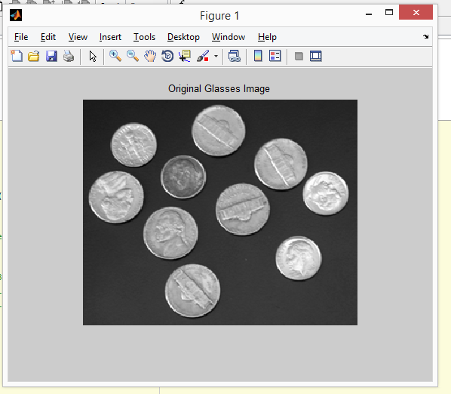
Figure S1: The original image as input
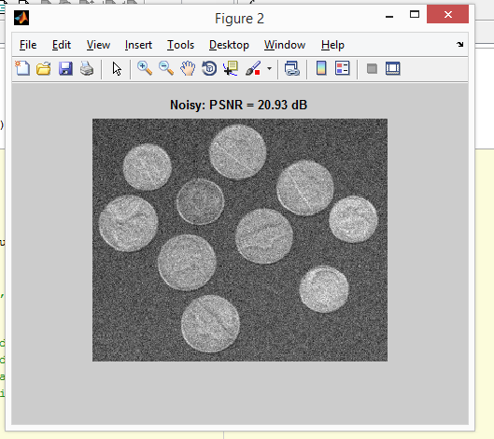
Figure S2: The noisy image with PSNR= 20.93 dB
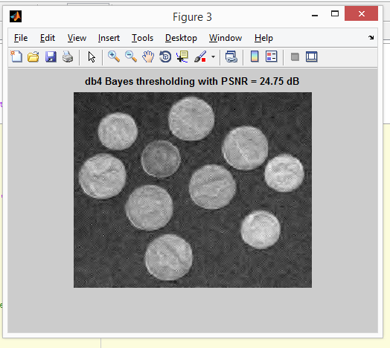
Figure S3: The restored image with PSNR = 24.75 dB

REFERENCES
[1]M. Banham and A. Katsaggelos, “Digital image restoration,” IEEE Signal Process. Mag., vol. 14, March. 1997.

[2]William Robson Schwartz , Helio Pedrini, Ricardo Dutra da Silva, “Adaptive edge-preserving image denoising using wavelet transforms ,”.

[3]M. R. Banham and A. K. Katsaggelos, “Digital Image Restoration,” IEEE Signal Proc. Magazine, March 1997.

[4] Rafael C. Gonzalez, Richard E. Woods, Steven L. Eddins Digital. Digital image processing using MATLAB.

[5]Rafael C. Gonzalez, Richard E. Woods. Digital image processing. Second edition upper saddle River, NJ: Prentice Hall; 2002.

[6]K. R. Castleman, “Digital Image Processing,” 2nd ed. Prentice Hall, Upper Saddle River.

[7]W. K. Pratt, “Digital Image Processing,” 3rd ed., John Wiley & Sons, New York, 2001.

[8]Savita Gupta and Lakhwinder kaur, Wavelet Based Image Compression using Daubechies Filters.

[9]Maarten Jansen, Noise Reduction by Wavelet Thresholding, Springer –Verlag New York Inc.- 2001.

[10] D.L. Donoho, De-Noising by Soft Thresholding, IEEE.

[11] F. Ruggeri and B. Vidakovic, “A Bayesian decision theoretic approach to wavelet thresholding,” Statist. Sinica, vol. 9, no. 1, pp. 183–197, 1999.

[12] Y. Yoo, A. Ortega, and B. Yu, “Image subband coding using contextbased classification and adaptive quantization,” IEEE Trans. Image Processing, vol. 8, pp. 1702–1715, Dec. 1999.

[13] Yuan X, Buckles B (2004) Subband noise estimation for adaptive wavelet shrinkage. In: 17th international conference on pattern recognition, vol 4, pp 885–888

[14] Antoniadis A (2007) Wavelet methods in statistics: some recent developments and their applications. Stat Surv 1:16–55.

[15] Weaver J, Yansun X, Cromwell DHL (1991) Filtering noise from images with wavelet transforms. Magn Reson Med 21(2): 288–295.

[16]Adaptive Wavelet Thresholding for Image Denoising and Compression,S. Grace Chang, Student Member, IEEE, Bin Yu, Senior Member, IEEE, and Martin Vetterli, Fellow, IEEE

[17] Vipin Tyagi, Para Jain (2013) ,Spatial and Frequency Domain Filters for Restoring Noisy Images IETE Journal of Education,Volume 54

PERSONAL DETAILS

Name: Ashutosh Shukla  Enr No.: 111224  Branch: CSE  Email Id: ashutosh111224cse@gmail.com  Permanent Address:82/19 Gandhi Gram ,Indrapuri Kanpur (U.P.)-208007  Phone No.:8962630781 | 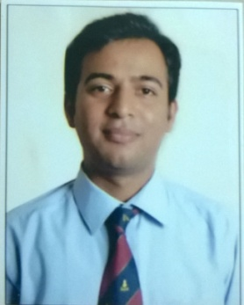
Name: Samrita Sen Bakshi  Enr No.: 111281  Branch: CSE  Email Id: samrita111281cse@gmail.com  Permanent Address: House No. 64 Man Vihar Colony, Shamshabad Road, Agra(U.P.)-282001  Phone No.: 7049511407 | 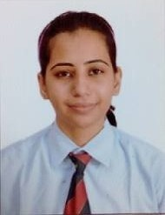
Name: Shivam Goyal  Enr No.: 111290  Branch: CSE  Email Id: shivam111290cse@gmail.com  Permanent Address: D-148 Ranjeet Nagar, Bharatpur (Rajasthan) -321001  Phone No.: 9770265563 | 

